Engineering 112C Energy Project

February 9, 2011

Team 18

David Applegate

Ryan Albrecht

Katie Wilkinson

Alejandra Europa Casanueva

Introduction

The Office of Utilities and Energy Management provided us with the data collected of energy usage for the months of January and September for several buildings on campus. The energy usage was broken into three categories: electrical, heating, and cooling. We will compare energy consumption throughout each month: energy usage during the day, during the night, and the total energy for each building. To take into account the fact that the size of the building might affect energy consumption of the building, we also found the energy usage as a function of square footage. Our goal is to compare the Jack E. Brown building to the other buildings on campus to determine if the energy consumption of the Jack E. Brown building is significantly higher than the others, and we want to determine whether HVAC or electricity uses more energy.

Methods and Materials

Given the data for the several buildings, our group used Microsoft Excel to make graphs and tables that allow us to compare our building, Jack E. Brown, to other buildings on campus. Since our data was collected in different units, we first converted the energy into BTUs. Once we had all the data in the same units, we calculated the average energy used over the month. Then, we found the daily average energy usage for each building. In order to do this, we averaged the total amount of electrical, cooling and heating energy used in January and September separately. To obtain hourly energy usage, we divided the daily average by 24, and to obtain the average use of energy per minute we divided the hourly average by 60. In order to calculate the average energy used by day, we separated the data into “day (8am-6pm) and night (6pm-8am) Excel worksheets” for each building. We used a clustered column graph to graphically compare the electrical and HVAC energy usage during the day and night for each building and month.

Then, we created three tables (January, September, January and September) to summarize our data. The first two tables show the total amount of energy used for each category (electrical, HVAC, total). We highlighted the cells in yellow for to indicate which component of each building uses more energy. We then added up the electrical and HVAC energy used by all the buildings and used green to show which category (electrical or HVAC) used the most energy. The red shows which building used the most energy overall. The third table shows the total energy used, total HVAC energy, and total electrical energy used by all the buildings during the two months. We used these tables to rank energy usage, both electrical and HVAC, for all buildings. To graphically show this data we made a pie chart to illustrate the percentage of total energy each building used.

The first step to calculating the energy used as a function of square footage, was to sum all of the energy used throughout the year. After obtaining the totals for each building, all we had to do was divide by each building’s square footage. Once we had that, we plotted the data as scatter plots, one for each type of energy. Ranking them was done by sorting the energy usage from greatest to least and assigning them ranks. The process of doing the equivalency chart began by taking the energy totals for all the other buildings, and dividing by the energy used by the Brown building (Repeated twice for both sets of energy). Once the ratios were obtained, we graphed them on a bar graph displaying them.

Results:

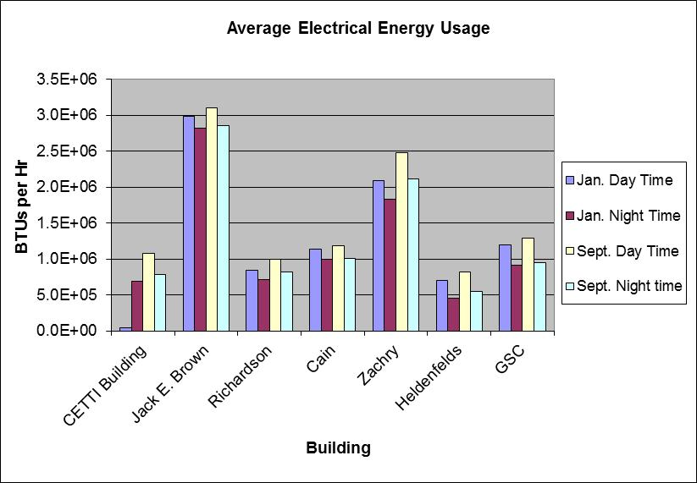

Figure

Figure 1 is of the average electrical energy usage amongst the given buildings. This graph compares their usage during different times of day, and by different seasonal months.

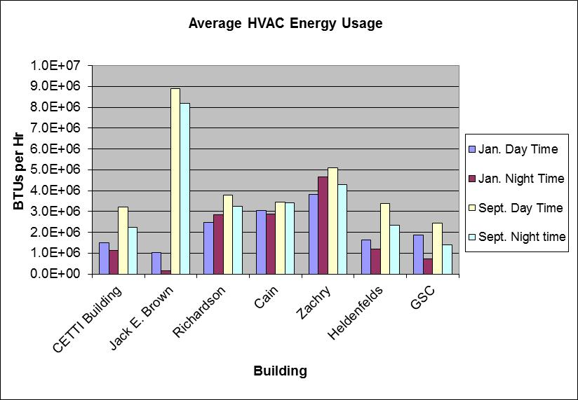

Figure

Figure 2 is of the average HVAC energy usage amongst the given buildings. This graph compares their usage during different times of day, and by different seasonal months.

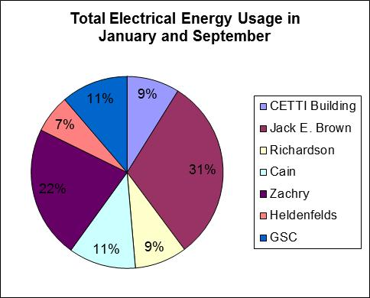

Figure

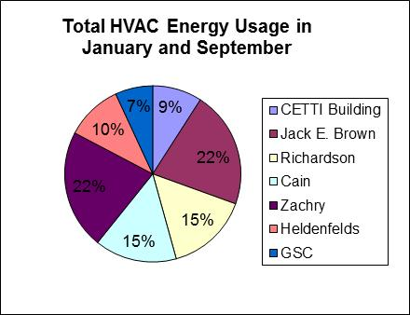

Figure

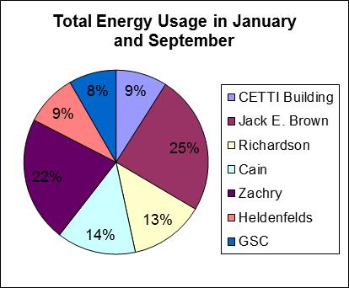

Figure

Figures 3, 4, and 5 are all pie graphs that relate the energy usage amongst the buildings based on their percentage of the total amount of energy used across campus. Figure 3 is Electrical Energy, Figure 4 is HVAC energy, and Figure 5 is both Electrical and HVAC together.



Table



Table



Table

Tables 1, 2, and 3 are all the average amounts of total energy used for the buildings during the month of January. Table 1 is the average per hour, Table 2 is the average per day, and Table 3 is the average per minute.



Table



Table



Table

Tables 4, 5, and 6 are all the average amounts of total energy used for the buildings during the month of September. Table 1 is the average per hour, Table 2 is the average per day, and Table 3 is the average per minute.



Table 

Table



Table



Table

Tables 7-10 all show the average amount of energy usage amongst the buildings in BTUs/hr. Tables 7 and 8 are for the month of September (7 is for night time, 8 is for day time). Tables 9 and 10 are for the month of January (9 is for night time, 10 is for day time)



Table



Table



Table

Tables 11, 12, and 13 show the total amount of electrical energy, HVAC energy, and total energy used for the buildings. Tables 11 and 12 are for January and September respectively, and Table 13 is the months of January and September combined. The cells highlighted in yellow represent which energy was more greatly used for each individual building (electrical or HVAC). The green highlighted cell represents which type of energy was more greatly used for all the buildings combined. The red highlighted cell represents which building used the most total energy.



Table



Table

Tables 14 and 15 rank the buildings by the amount of energy that they use. Table

14 ranks them by use of electrical energy while table 15 ranks them by HVAC energy.



Figure 6

Figure 6 refers to the total energy used on water as a function of total square footage.



Table 16

Table 16 ranks the energy used on water per square foot in order from greatest to least.



Figure 7



Table 17

Figure 7 and Table 17 discuss the energy used on electricity per square foot. The scatter plot maps consumption as a function of area, while the table ranks the buildings from greatest consumption to least consumption.



Figure 8



Table 18

Figure 8 and Table 18 discuss the ratios of Energy/Square foot of all the other buildings in comparison to the Jack E. Brown building. Figure 8 maps how many of each building’s consumption it would take to add up to the Brown building, while Table 18 contains the raw ratios, expressed as Brown/Building.



Table 19

Table 19 contains the raw data used in Figure 6 and Figure 7, with the totals for square feet, electricity, and water energy. The data for water energy on the Brown building is a bit skewed, since the readings for chilled water were far too low to be reasonable. However, it should be noted that Brown was still one of the highest consumers of energy.

Discussion:

By evaluating Figure 1 and 2, we can see that generally the buildings use more energy during September than they do in January. The graphs also show that energy is used more during the day hours than during the night hours. The data supports a reasonable conclusion, since we have to use so much more energy during the summer months to lower the temperature, and not as many people are in the building during the night hours, so not as much energy is used. By evaluating Figures 3, 4, and 5, it is safe to assume that Jack E. Brown and Zachry use around the same amount; the CETTI Building, Heldenfelds, and the GSC use around the same amount of energy; and that Richardson and Cain use about the same about. The Jack E. Brown building and Zachry were consistently using the most energy. Based on Tables 11-13, HVAC energy was more greatly used than Electrical energy. In general the consumption increased with the square footage of the building, however this was not true for all buildings. While some buildings use lots of energy due to the sheer size of the building, others needed to use more energy because they contained an abundance of electronic equipment.

Conclusion:

Our building, the Jack E. Brown building, used the most electrical energy amongst the buildings while it came in second in ranking for HVAC energy to Zachry. During September, Jack E. Brown used a significantly larger amount more energy (mostly HVAC energy) than all the other buildings. We conclude that the reason why Jack E. Brown uses so much energy is because it is hard to keep a building made mostly out of windows cool during the hot months. In the end, the Brown building is very aesthetically pleasing, but not very energy efficient.

Works Cited

Annamalai, Kalyan, and Ishwar K. Puri. "Appendix A." Combustion Science and Engineering. Boca Raton [u.a.: CRC, 2007.

Potter, Merle C., and Craig W. Somerton. "Appendix A." Schaum's Outline of Theory and Problems of Thermodynamics for Engineers. New York [u.a.: McGraw-Hill, 1995.